**Metroidvania Map Kit**

**Introduction**

The Metroidvania Map Kit allows you to construct map functions in Metroidvania games through a few simple configuration operations,including the small map in the upper right corner of the game interface ,the large map ,and operations such as moving and zooming after opening the large map.

**Components**

**LargeMapController**:

It provides interactive operations after the large map is opened.

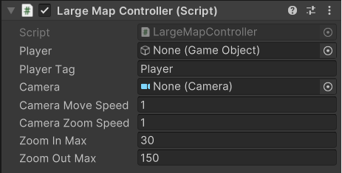

**Player**:the player object

**Player** **Tag**:the tag of the player object.it will take effect when player parameter is null.

**Camera**:A camera that captured the large map

**Camera** **Move** **Speed**:default setting:1.the speed which the camera moves when a move camera command is entered

**Camera** **Zoom** **Speed**:default setting:1.the speed which the camera zooms when a zoom camera command is entered

**Zoom** **In** **Max**:default setting:30.this value limits the maximum size of the map when zooming in

**Zoom** **Out** **Max**:default setting:150.this value limits the maximum size of the map when zooming out

**MapRevealer**:

It provides the ability to uncover the map

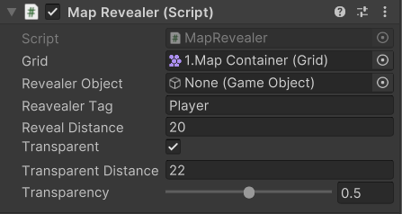

**Grid**: The Grid where the tilemap is located

**Revealer** Object: reveal the fog around this object

**Revealer** **Tag**: default setting: Player.Reveal the fog around this object with this tag, if the revealer object is null

**Reveal** **Distance**: default setting:20.The distance of fog revealed centered on the revealer object

**Transparent**:default setting:true.Is it necessary to add a translucent area between the opening and closing of the log

**Transparent** **Distance**:default setting 22.

**Transparency**:default setting:0.5

**MapSwitcher**:

It provides the function of swithing large maps on and off

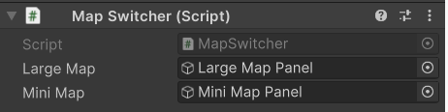

**Large** **Map**:the panel that contain the large map

**Mini** **Map**:the panel that contain the mini map